
Business Question and Visualization Report

Date | 1 November 2026
Team ID
Project Name | EV Market Performance & Insights Platform
Maximum Marks | 5 Marks

Visualization development refers to the process of creating graphical representations of data to facilitate understanding, analysis, and decision-making. The goal is to transform complex datasets into visual formats that are easy to interpret, enabling users to gain insights and make informed decisions. Visualization development involves selecting appropriate visual elements, designing layouts, and using interactive features to enhance the user experience. This process is commonly associated with data visualization tools and platforms, and it plays a crucial role in business intelligence, analytics, and reporting
Business Questions and Visualisation
The process involves defining specific business questions to guide the creation of meaningful and actionable visualizations using data stored in Snowflake. Well-framed business questions help identify the required metrics, determine the appropriate Snowflake tables or analytical views, select relevant data, and create visualizations that provide useful business insights.

Question/answer:
1. What is the total sales volume generated across all EV models?
- Code / Logic: SUM([Total_Sales]) aggregated as a single KPI metric.
- 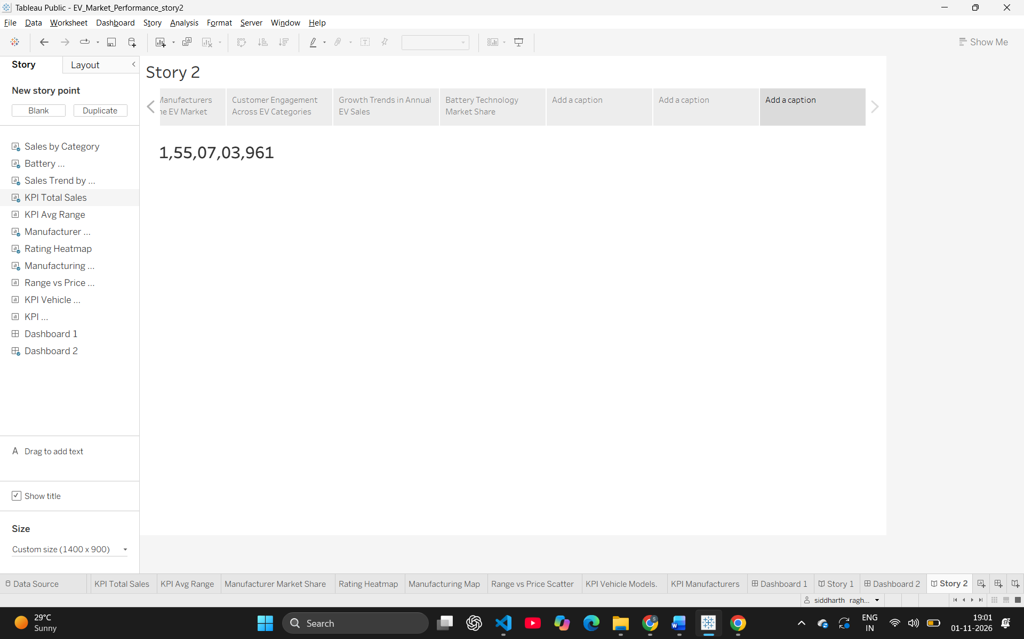
2. Which specific EV categories (e.g., Compact SUV, Hatchback) generate the highest total sales?
- Code / Logic: Placed [Category] on the Rows shelf and SUM([Total_Sales]) on the Columns shelf (Horizontal Bar Chart).
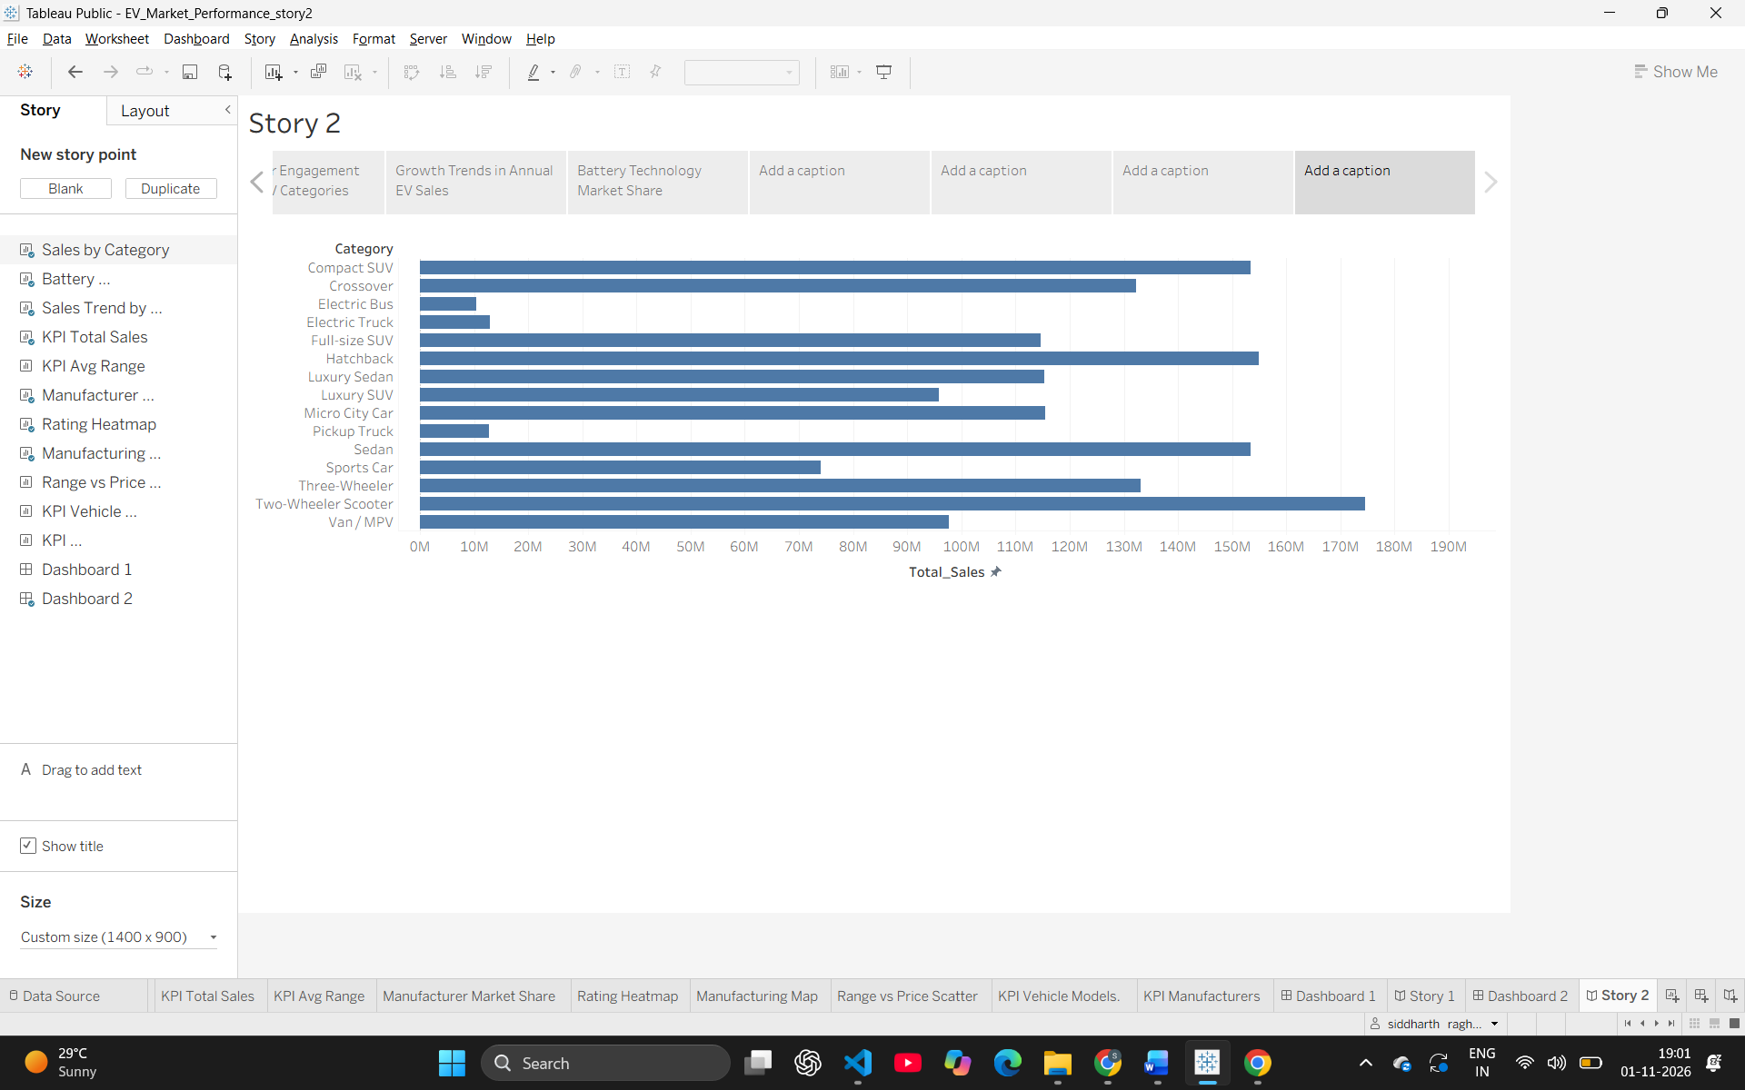3. What is the market share distribution of different battery technologies used in EVs?
- Code / Logic: Placed [Battery_Type] on Color and SUM([Total_Sales]) on Angle (Pie Chart).
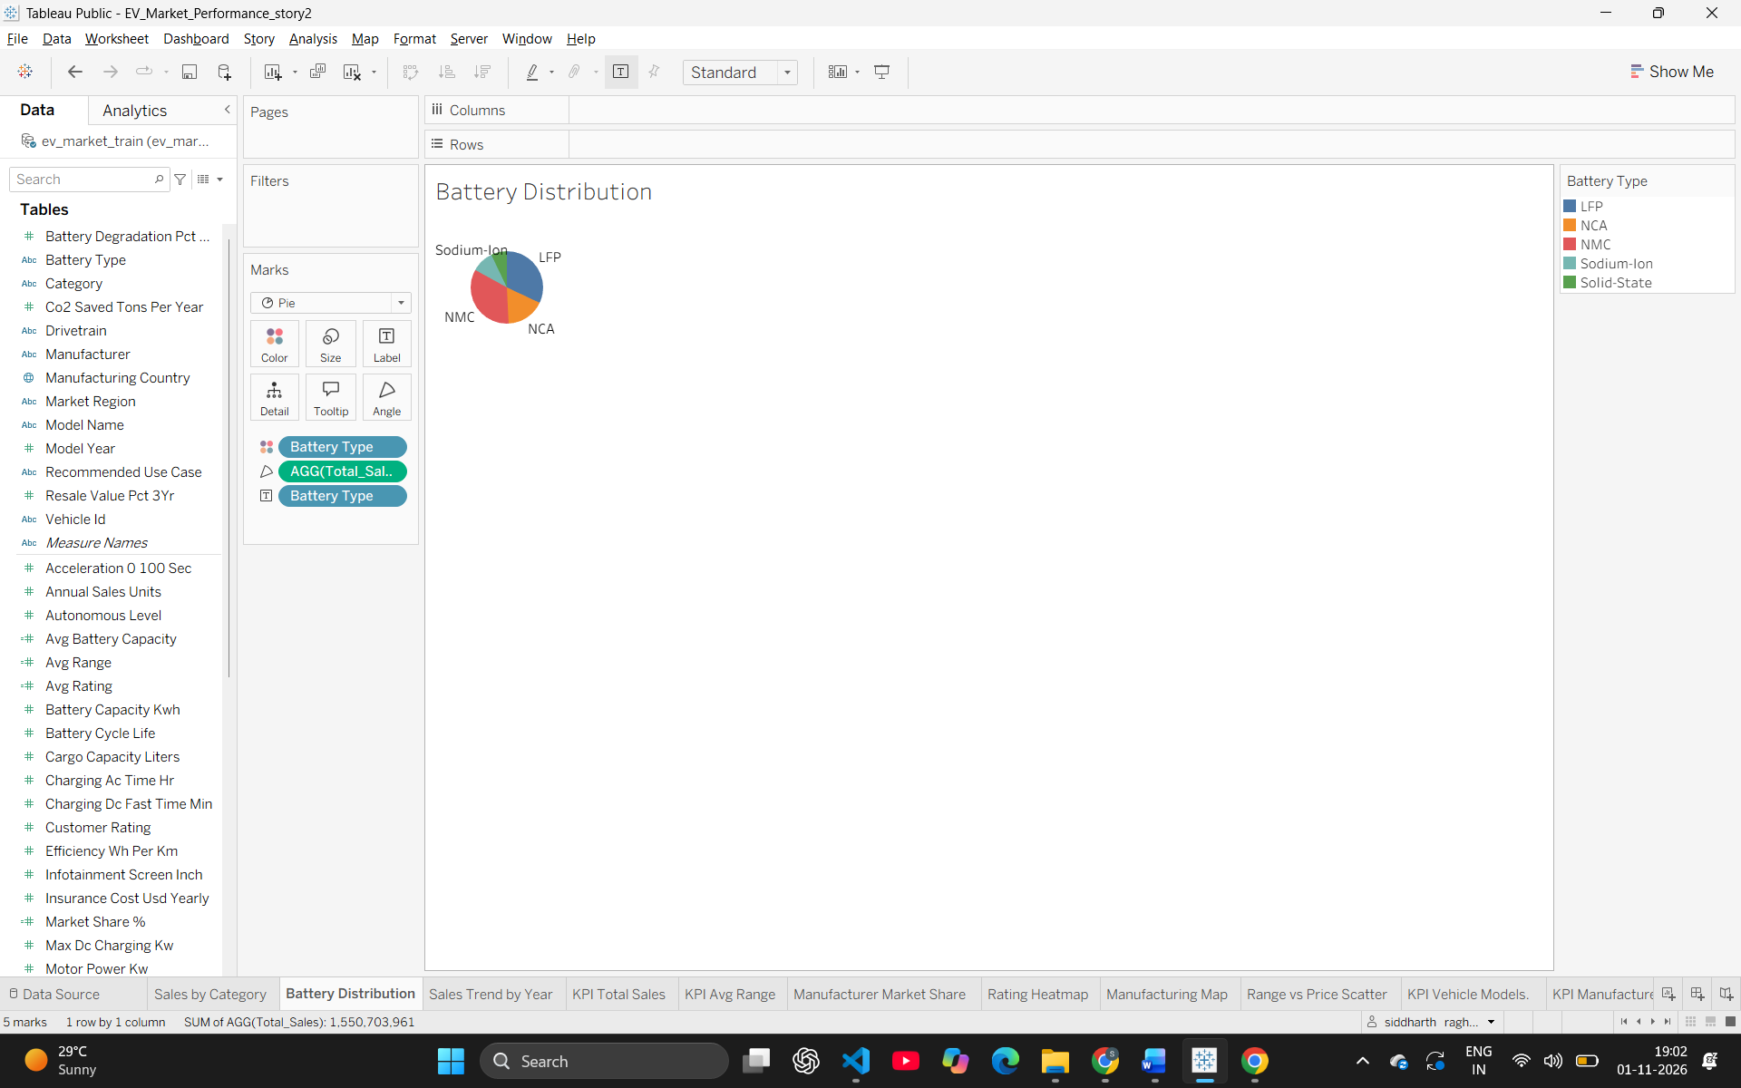4. Which manufacturers dominate the EV market share?
- Code / Logic: Placed [Manufacturer] on Color and SUM([Total_Sales]) on Angle (Donut Chart).
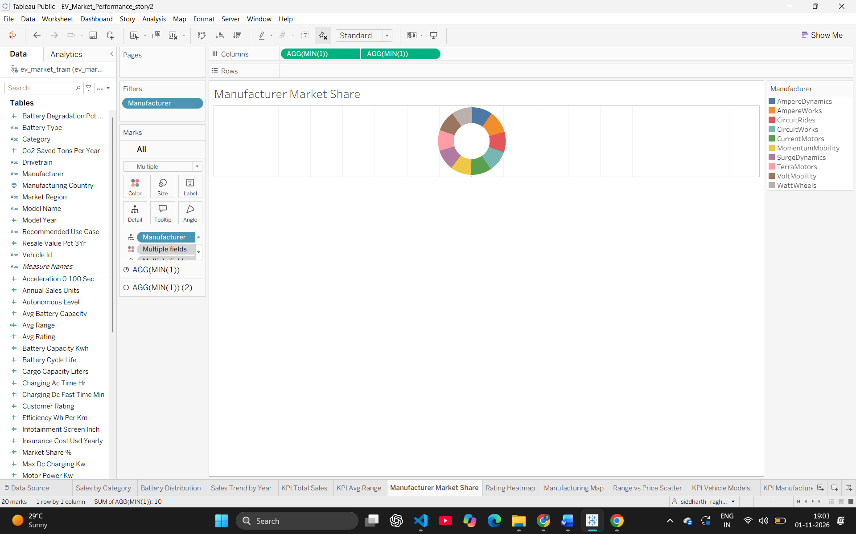5. How do customer ratings vary across different EV categories and battery types?
- Code / Logic: Placed [Battery_Type] on Rows, [Category] on Columns, and AVG([Rating]) on the Color mark (Heatmap).
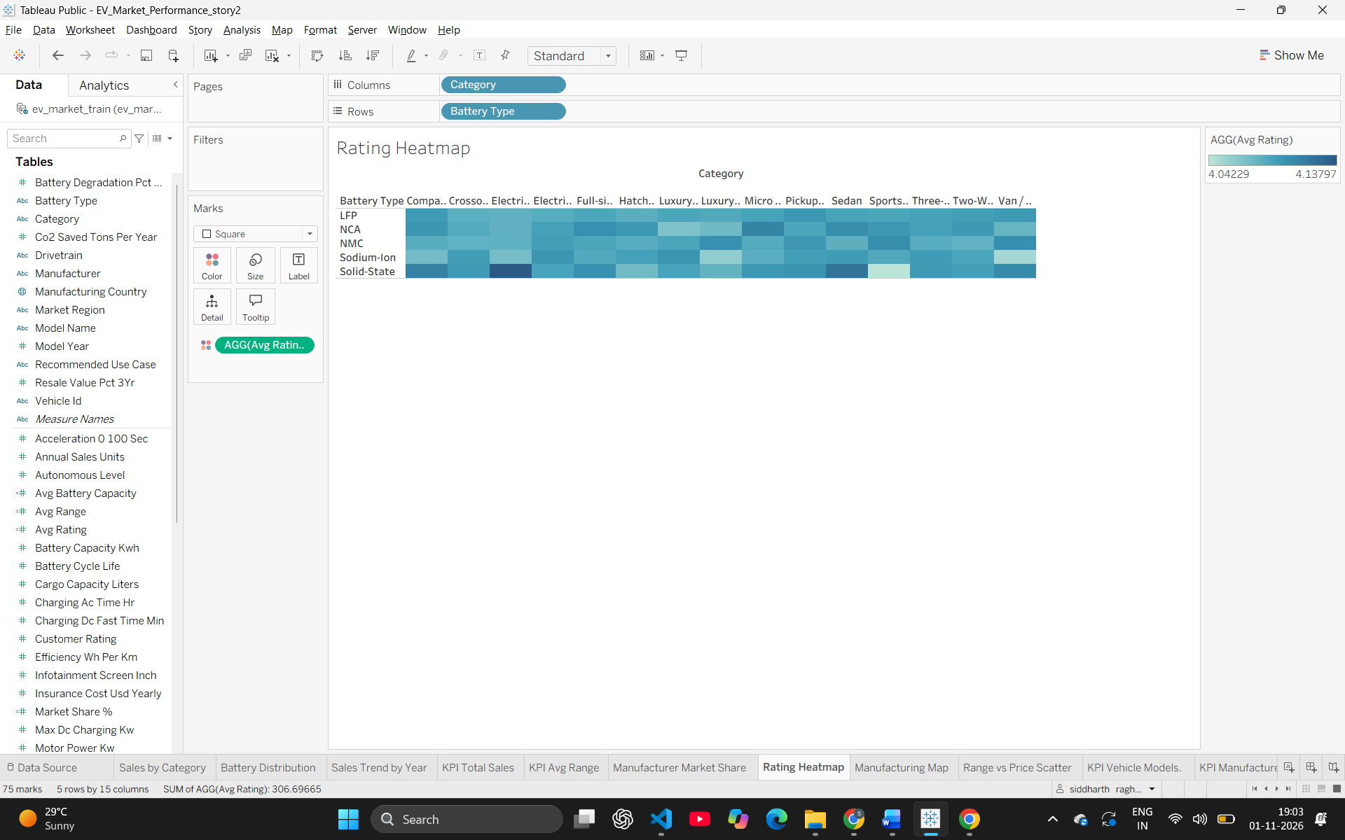6. How has the total sales trend evolved year-over-year from 2017 to 2026?
- Code / Logic: Placed [Model_Year] on Columns and SUM([Total_Sales]) on Rows (Line Chart).
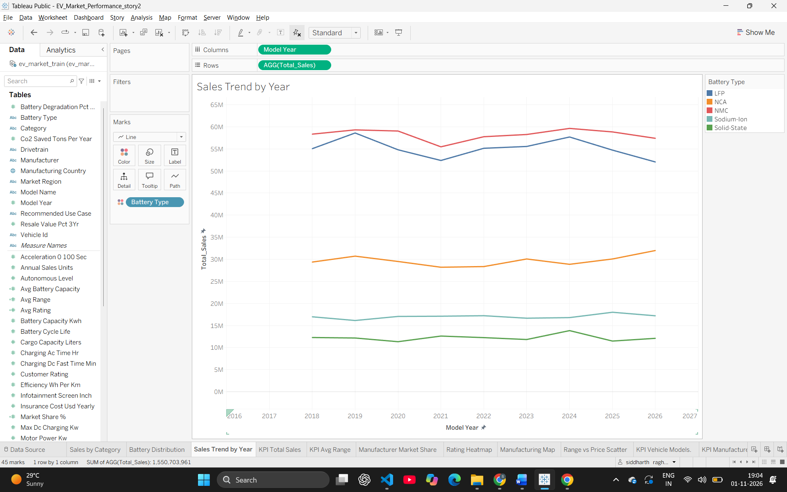7. Where are the primary global manufacturing hubs located for these EV models?
- Code / Logic: Placed [Country/Region] on the Detail mark to generate the geographic filled map.
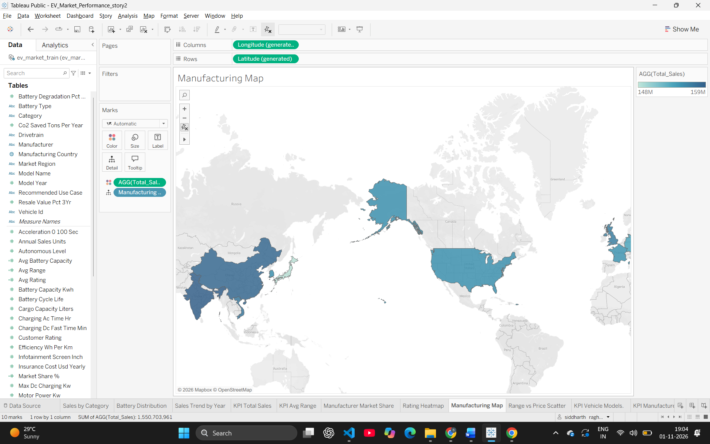8. What is the correlation between an EV's driving range and its selling price?
- Code / Logic: Placed [Range] on Columns and [Price] on Rows to identify clusters/trends (Scatter Plot).
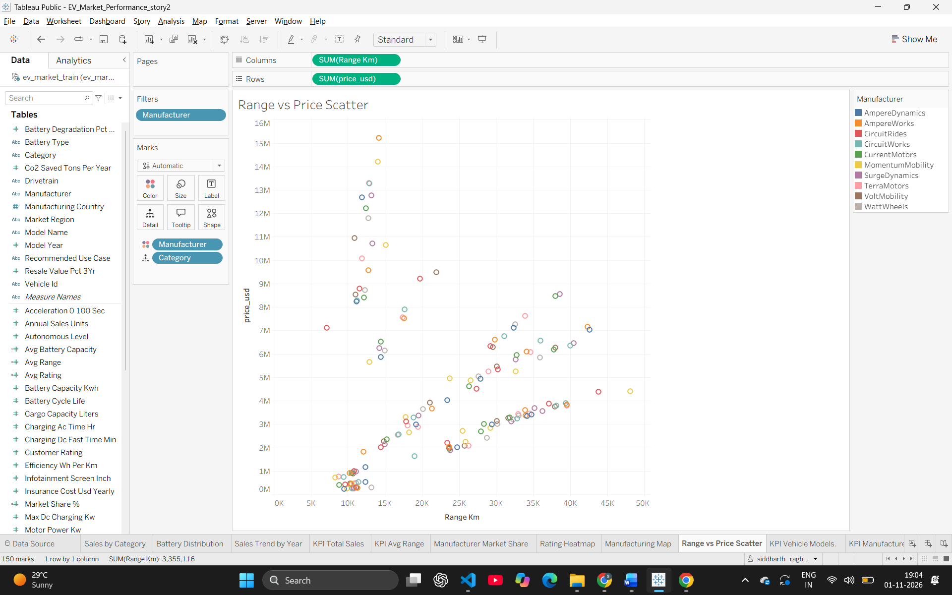
Note: Min 8 business question and visualisations Required inform of above

